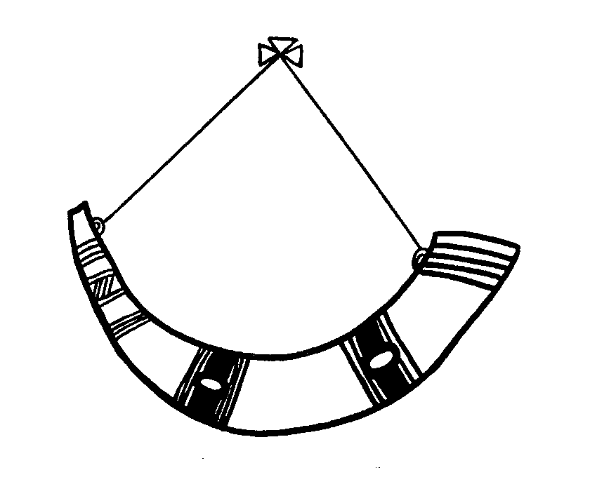

Inspiring Learners to Grow Bright Futures
Crathes School

Relationships, Sexual Health and Parenthood Education Policy April 2024

The purpose of this policy is to give staff, parents/carers and pupils guidance on how Relationships, Sexual Health and Parenthood Education is approached at Crathes School.

Staff have created this policy collaboratively, in consultation with parents, and with consideration of UNCRC and reference to educational research.

There are several articles in the UN Convention on the Rights of the Child that relate to a child’s right to education. Articles 28 and 29 of the Convention on the Rights of the Child focus on a child’s right to an education and on the quality and content of education, while Article 24 relates to a child’s right to the best possible health.

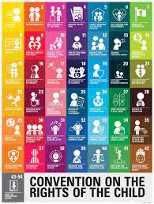

Crathes School promotes health in its widest sense, considering the physical, social, and emotional wellbeing and development of our pupils at all times. Relationships, Sexual Health and Parenthood (RSHP) is one of the six key areas within the Health and Wellbeing curriculum. All schools are required to provide and deliver this education in an objective, balanced and sensitive manner within a framework of sound values. We strive to achieve this in Crathes School.
Our teaching and learning resources support and delivery of this area of the curriculum (RSHP). All content is age and stage appropriate for learners 5- 12 years, organised by Curriculum for Excellence Levels, from Early Level through to Second Level.

This policy lays out a broad statement of our planned teaching within this curricular area, however we aim to be responsive to individual learner’s needs and we will work closely with families to plan individual learning programmes, where appropriate.

Details of the RSHP Programme
Topics within the RSHP programme include:
- Body autonomy, consent and protection from harm
- Emotional wellbeing and help-seeking behaviour
- Equalities and inclusion
- Gender equality and discrimination
- Parenthood and families
- Relationships and friendships
- Sexual health and reproduction
Skills that the RSHP programme will help to develop:
- Self- regulating emotions
- Self-esteem and confidence
- A positive attitude towards differences and diversity
- Treating others with respect
- Making informed choices
- Build and sustain relationships
- Access help and support when necessary
- Managing risk

Learning Across all Levels
That all families are different; and gain an understanding that people who are important to the children provide care and love.
That people are individual and unique.
About the similarities and differences (diversity).
Looking after their body and keeping clean.
Making choices and decisions.

Early Level P1
At Early Level the children learn:
Names for parts of their body and that some parts of their body are private.
To recognise and express their feelings, including when they might feel safe or unsafe, happy, or worried.
To identify adults that they can go to if they have a question or a worry, introducing the idea of trust.
Where living things come from.
The needs of plants, animals, and babies.
That there are professional people who help and care for them.

First Level – P2 to P4
At First Level the children learn about:

The different adults who might care for children, beyond their immediate family network, such as teachers, support staff in school.
Recognising what makes them an individual and determining the kind of person they want to be.
Respect for others and the importance of being kind.
How their bodies change as they grow.
Parts of their body are private. Other people should not touch the private parts of their body.
What behaviour is okay in public and what is okay in private.
The life cycles of plants and animals.
What a baby needs and how to care for a baby.

Second Level P5-P7
At Second Level the children learn about:

Recognising what makes them an individual and determining the kind of person they want to be.
Loving relationships and being attracted to others.
Feeling safe and unsafe.
Different kinds of abuse and neglect that can happen to a child.
What we mean by consent.
Who they can go to for help and support.
Puberty and how bodies and emotions change as people grow.
What ‘having sex’ is, including reference to contraception.
How a baby is made (conception), pregnancy and how a baby is born.
Being a parent and thinking about what kind of parent they would be.

Home-School Links
We recognise how important it is that both home and school, work together in delivering this important area of the curriculum. Parents will be informed by email of the start date and content of the RSHP programme that their child will be covering. This is to support discussion at home as appropriate.
We feel it is important that parents are very clear as to how we will approach discussions of RSHP in school. We recognise that families sometimes have special names for their body parts, but it is important that the children know and use the correct terminology as we will be referring to these at school. We will encourage the correct usage of terminology for body parts.
At Crathes School we will answer any questions that the children may have during the lessons with honesty, sensitivity and in an age-appropriate manner. We will reassure the children that body changes are normal and that these changes happen to everyone at different times.
We know that families are made up in lots of different ways and it is important that we recognise and celebrate these differences. We will be led by the needs of the school community and the children within it when opening up these discussions.

The RSHP resources can be viewed by parents by contacting the School Office.
We will be open to supporting any communication between home and school that is appropriate to meet the needs of our learners in this curricular area.

Policy Review: June 2026

